TC-DVA-009
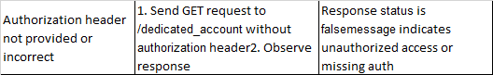
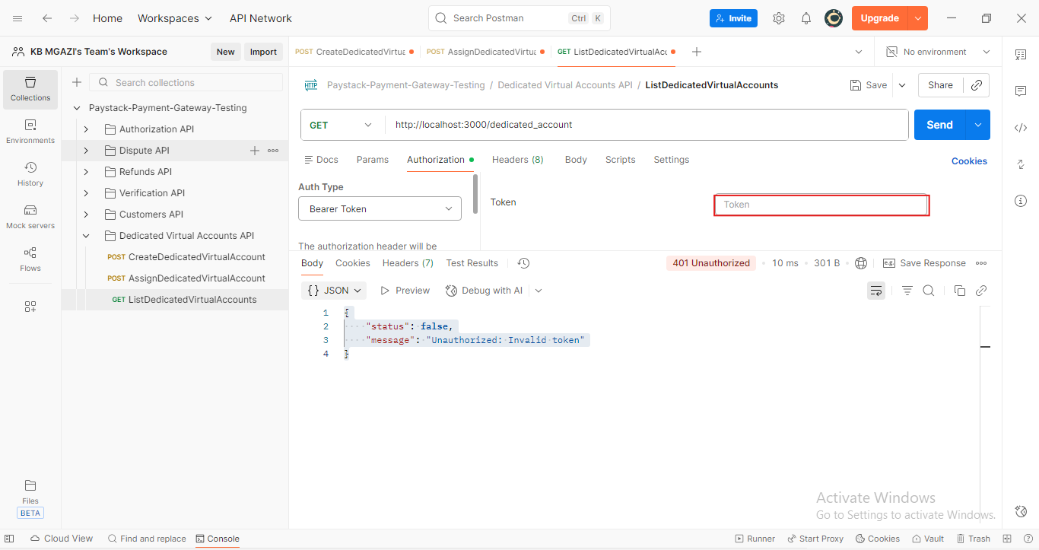
Response:
{
"status": false,
"message": "Unauthorized: Invalid token"
}

